Unit 3 Calendar
Organic or Traditionally Grown Food
GM Foods Yes or No
Food Industry Safe or Not
How do Foods Change our Lives?
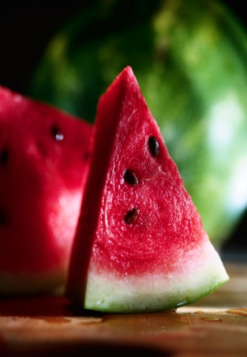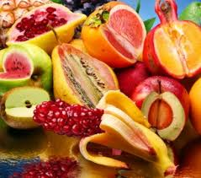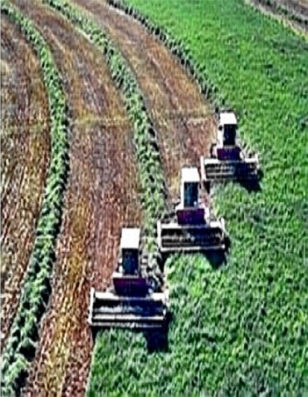

DUE DATES
Watch video Food, Inc. # 3 – January 7
Take part in a book discussion on one of the four books # 1 & # 2 – March 3
Take part in a book discussion on The Jungle # 6 – January 27
Research # 4 & # 10 is due – February 4
Watch video Food Nation # 7 – January 22
Oral Presentation # 8 – February 24-28
Deconstruction # 9 – February 12
Watch video How I Fell in Love with a Fish # 5 – February 18
Essay Preparation is due # 11 – February 28
Essay due (1750-2000 words) #12 – March 5

